
Funding Public Schools

Background:

Public school funding in Iowa has failed to keep up with demand. Schools are cutting programs such as fine arts, foreign languages, or even staff such as school nurses and guidance counsellors. Class sizes remain too big. Educational resources may be limited or outdated, and teachers often must fund their own classroom supplies. School dining programs struggle to stay afloat, and academics are slipping.
Democrats understand that education is an investment in our future. To remain on the forefront of education, we must equitably increase funding for our public schools so they may adapt to the changing needs of the 21st Century. This session, we will work to increase funding to a more adequate amount so schools will have the resources they need to operate to the best of their ability. There are four main areas we would especially like to see increased resources for.

Facts:

Staffing:
- Iowa ranks 21st in average teacher salary. The average teacher salary in Iowa was about $57,000 in 2019, well under the average $60,000 a year nationwide
- Studies suggest that increasing teacher pay may have a positive effect on retention, as well as make the job more competitive and lucrative for qualified individuals
- Student to teacher ratio is still around 19:1, despite our goal of 17:1
- Districts are consolidating guidance counseling, media specialist, and nurse positions
- Studies show that equitable funding can increase student academic success

Programming:
- Schools are reducing the number of activities and foreign languages to save money
- Extracurricular participation is linked with improved academic performance, interpersonal skills and offers students opportunities to explore interests and develop life skills, such as time management, teamwork and leadership

Resources:
- Students largely must buy their own school supplies
- Teachers usually must make up for any lack of supplies, lest students be left unprepared

Services:
- 1 in 7 children in Iowa are food insecure
- Studies show that a healthy diet promotes increased cognitive function, better behavior, and improves overall academic performance

General:
- GOP Lawmakers failed to pass supplemental state aid at 3%
- Increased funding leads to equitable improvements in student achievement, especially in high-poverty districts
- Iowa spends on average about $7,900 per-pupil, leading to a disparity of almost $700 between the lowest and highest funded districts

Our plan for ensuring adequate funding

Democrats understand that our students are our future, and we need to prepare them for the unique challenges and opportunities they will face in the 21st Century and beyond. We need to enable our students to find a career that suits them. Our teachers and staff must be properly equipped to educate our students to the best everyone’s abilities, but also properly compensated and given a manageable workload to facilitate this. While there is a lot when it comes to funding our public school, we can focus on increasing funding in four big areas.
- Incentivize teaching: Ensure there is enough money to hire more teachers and other staff, but also pay them more.

- Fund programming: Ensure that there is funding so that all our students have access to a wide variety of extracurriculars, whether it be sports, fine arts, agriculture, industrial technology, engineering, or other programs.

- Equip our schools: Ensure that schools have enough classroom supplies and modern resources, media and technology.

- Serve our students: Ensure that schools have funding for quality nutrition, physical and special education programs.

Key points: Adequate funding facilitates effective education

Proper staffing
- We must hire enough teachers/administration to manage the workload
- Full staff
  - Nurses, guidance counsellors, custodial, etc.
- More lucrative pay
  - Need highly qualified, motivated, professionals in our public schools

Programming
- Schools should offer a variety of extracurriculars to encourage exploration in a variety of interests and future career fields. Cutting these programs diminishes the experience and opportunities for our students.
- Schools should also offer a variety of foreign languages to encourage cultural exploration
- Bring programs back
  - As part of equitable funding, we should aim to restore programs that have been slashed due to budget cuts.
Resources
- School supplies
  - Teachers should not have to personally fund school supplies that their students can’t afford.
- Modern educational resources/media
  - Students need access to technology, as well as relevant and accessible learning and research materials.
Services
- Nutrition/Physical Education
  - Students need to receive quality food to sustain them.
- Special Education and accelerated learning programs

Social Media
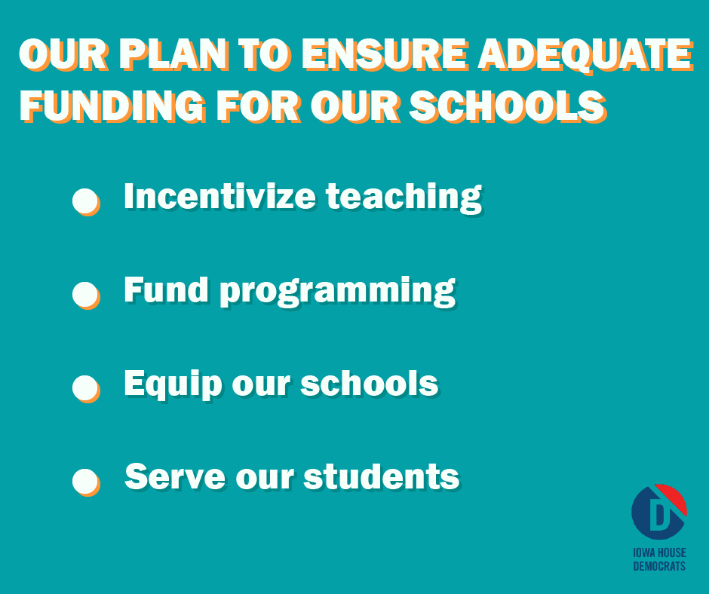
Sample Text:
There are many needs when it comes to properly funding our public schools. Here are some key areas we can focus on to ensure we are meeting students needs!

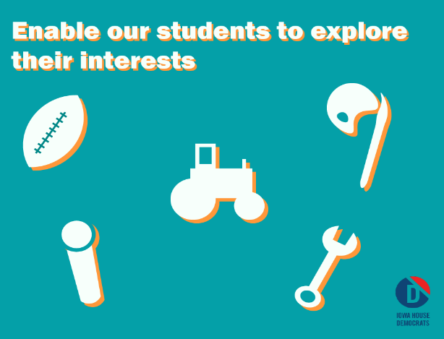
Sample Text:
Students are our future. They should have access to a variety of extracurricular activities to allow them to explore interest options and career opportunities that best suit them.
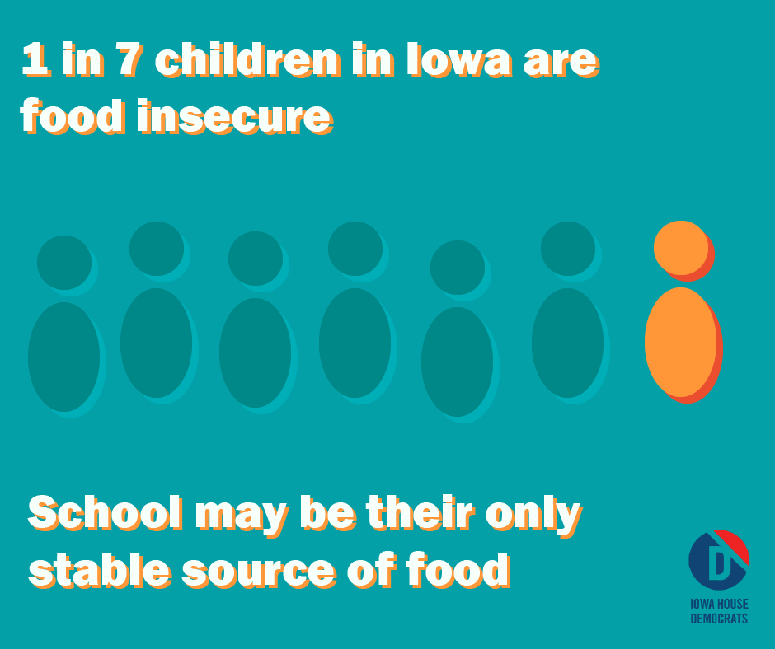
Sample Text:
1 in 7 children in Iowa are food insecure. School is oftentimes the only stable source of food for children. Dining programs need support to provide healthy, filling meals for our students.
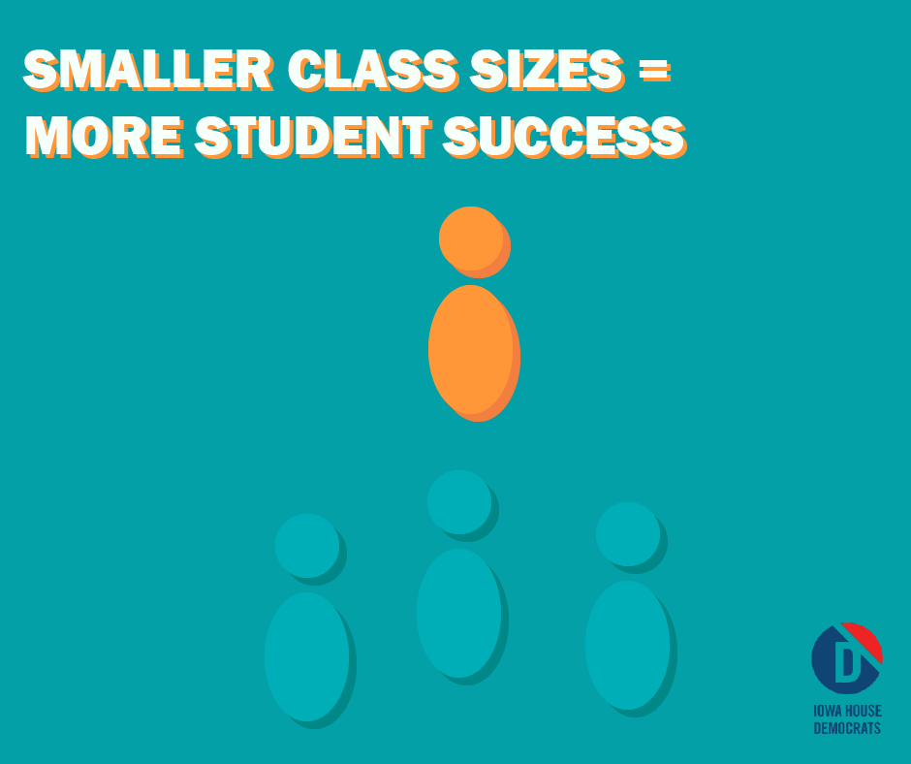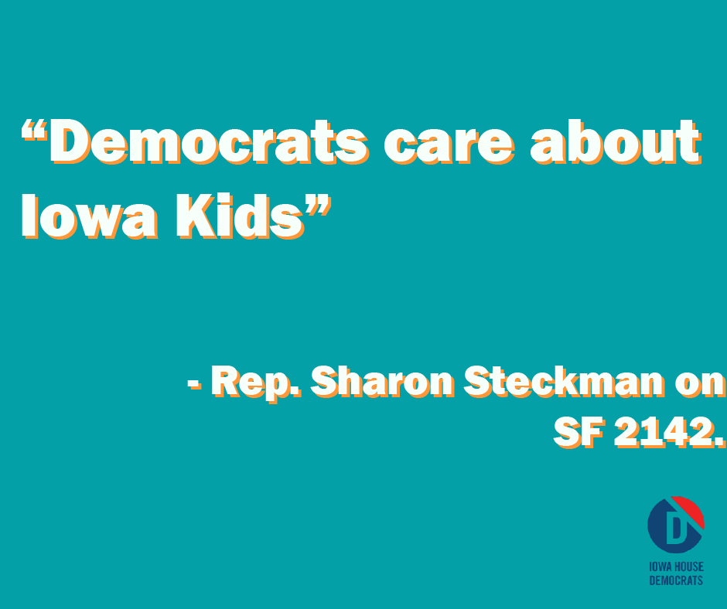

Sample Text:
Studies show lower class sizes improves a student’s educational experience. The average class size in Iowa is 19. We must hire more teachers!

Sample Text:
Democrats care about Iowa kids. It is time we fund supplemental state aid at least 3%. Our public schools are lacking the resources they need to best serve our students.
Sources
3 Ways Nutrition Influences Student Learning Potential and School Performance. (Healthy Food Choices in Schools, 2019). https://healthy-food-choices-in-schools.extension.org/3-ways-nutrition-influences-student-learning-potential-and-school-performance/
Baker, B. D. How money matters for schools. (Palo Alto, CA: Learning Policy Institute, 2019). https://learningpolicyinstitute.org/sites/default/files/product-files/How_Money_Matters_REPORT.pdf
Condition of Education. (Iowa Department of Education, 2019). https://educateiowa.gov/sites/files/ed/documents/2020-01-23ConditionOfEducation2019.pdf
District Cost Per Pupil. (Iowa Department of Management, 2019). https://dom.iowa.gov/document/district-cost-pupil-fy2020
Hunger in America. (Feeding America, 2019). https://www.feedingamerica.org/hunger-in-america/iowa
Maloney, Emily, Carbonaro, William. Extracurricular Activities and Student Outcomes in Elementary and Middle School: Causal Effects or Self-selection?. (Sage Journals, 2019). https://journals.sagepub.com/doi/full/10.1177/2378023119845496
SF 2149. (Iowa Legislature)

Condition of Education (2019). Iowa Department of Education.
Baker, B. D. (2017). How money matters for schools. Palo Alto, CA: Learning Policy Institute.
Condition of Education (2019). Iowa Department of Education.
Condition of Education (2019). Iowa Department of Education.
Baker, B. D. (2017). How money matters for schools. Palo Alto, CA: Learning Policy Institute.
Maloney, Emily, Carbonaro, William. Extracurricular Activities and Student Outcomes in Elementary and Middle School: Causal Effects or Self-selection? (2019). Sage Journals.
What Hunger Looks Like in Iowa. Iowa | Feeding America (2019)
3 Ways Nutrition Influences Student Learning Potential and School Performance. Healthy Food Choices in Schools (2019)
SF 2142. Iowa Legislature.
Baker, B. D. (2017). How money matters for schools. Palo Alto, CA: Learning Policy Institute.
District Cost Per Pupil FY2020. Iowa Department of Management

